PRESS RELEASE

Teams from Poland and the Netherlands secure victory at Volvo CE Masters 2026 European Final

After an intense competition at the Volvo CE facility in Konz, Germany, Team Golden Boys, Volvo Maszyny Budowlane Poland and Team The Dutchies from SMT Netherlands B.V. have secured their place in the 2026 Volvo CE Masters World Final — demonstrating outstanding technical expertise, teamwork, and problem-solving under pressure.

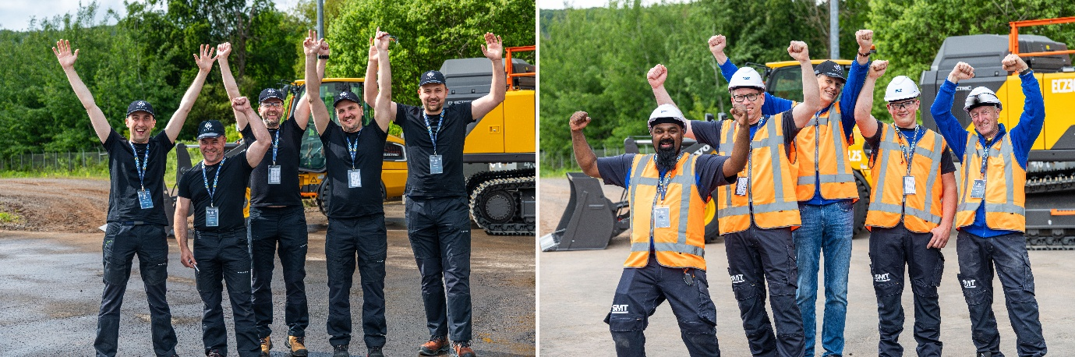
Team Poland and the Netherlands qualify for the Volvo CE Masters World Final
Volvo Maszyny Budowlane Poland and SMT Netherlands B.V. have won the 2026 European Regional Final of Volvo CE Masters — The Battle of Skills, outperforming teams from Volvo CE's European dealer network in one of the most technically demanding competitions in the global construction equipment industry.
Following three rigorous online qualification rounds focused on technical expertise and Volvo product knowledge, eleven of the top-performing teams earned their place in the European Regional Final.
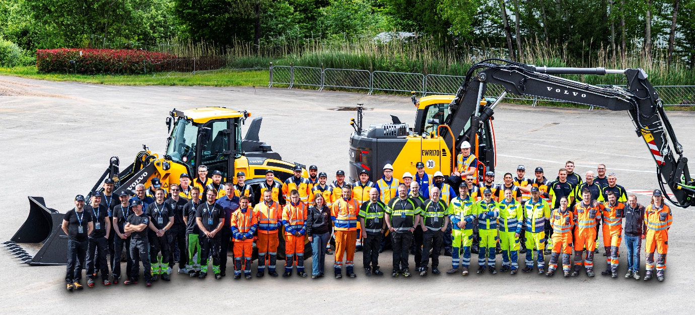
The in-person final in Konz put competitors through a series of hands-on tests focused on machine diagnostics, product knowledge, troubleshooting, and teamwork under pressure.
Both winning teams demonstrated exceptional technical expertise, teamwork, and composure under pressure — reflecting the expertise and support customers rely on every day.

What winning here actually means
Volvo CE Masters is designed to test the same skills technicians use every day to keep customer machines running — diagnostic accuracy, efficiency under pressure, and the ability to solve complex challenges. The results reflect the dedication, experience, and teamwork that help customers maximize uptime and productivity.
Marcin Samborek, Head of Operations, Volvo Maszyny Budowlane Poland, said: “This win is the result of months of preparation and a team spirit that grew stronger every step of the way. We came together from different locations, different perspectives, and different strengths, and turned that into one united team. We’re incredibly proud of what we have achieved together, and we’re heading to the world final in Eskilstuna with excitement, confidence, and one clear goal: to win.”
Jan Fogelberg, Masters Global Lead at Volvo CE, added: “The standard in Konz was exceptional. Volvo Maszyny Budowlane Poland and SMT Netherlands B.V. stood out not just for what they knew, but for how they performed under real pressure. That combination is exactly what our customers experience from Volvo CE teams every day.”

The road to Eskilstuna
By winning the European Regional Final, the teams from Poland and the Netherlands have secured their place at the 2026 Volvo CE Masters World Final — to be held at the Volvo CE Customer Center in Eskilstuna, Sweden, in September 2026. There, they will compete against the top-performing teams from Volvo CE regions across the world, including Europe, Asia, China, North America, Latin America, India and the Sales Region International.
The 2024 World Final was won by Team Funky Mechanics from KSS Korea, who defeated then-European standout team SMT Netherlands in a closely fought final. That result — and the talent it took to produce it — sets the bar the teams from Poland and the Netherlands are now aiming for.

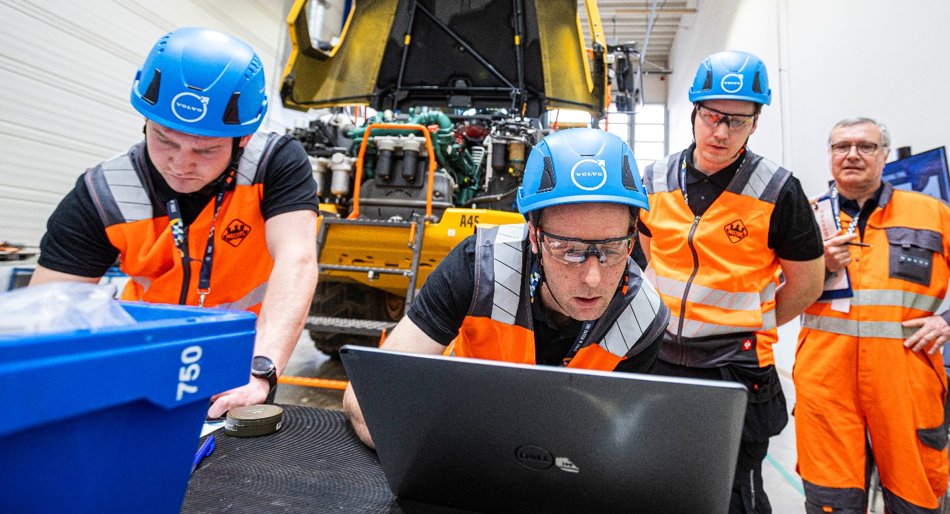

About Volvo CE Masters — The Battle of Skills
Volvo CE Masters is one of the largest technical skills competitions in the global construction equipment industry. Now in its 35th year, it challenges teams of aftersales professionals from authorized Volvo CE dealers worldwide to prove their expertise across practical machine challenges, product knowledge, and teamwork.
In 2026, close to 3,000 individuals entered the competition. The World Final takes place in September 2026 at the Volvo CE Customer Center in Eskilstuna, Sweden.

Follow the competition:
Facebook: facebook.com/volvocemasters

— END —
May, 2026

Journalists wanting further information, please contact:

Sandra Jansen
Media Relations & Communications Manager
Volvo Construction Equipment
sandra.jansen@volvo.com

For more information, please visit www.volvoce.com

For frequent updates, follow us on
LinkedIn: @Volvo Construction Equipment
Facebook: @VolvoCEGlobal
Instagram: @VolvoCE
YouTube: @Volvo Construction Equipment

Volvo Construction Equipment (Volvo CE) is a global leader in construction solutions, delivering premium products and services that combine power and performance with a more sustainable way of working. We are a company driven by people and together we have a purpose: To build the world we want to live in. Founded in 1832 and with a distribution network across every major market, our many dedicated experts around the world are fulfilling our shared purpose through a focus on sustainability, electromobility and services. As well as our expanding range of electric machines and charging solutions, Volvo CE provides industry-leading haulers, loaders, excavators and much more, all built to suit the demands of our customers’ varied construction and infrastructure needs. Volvo CE benefits from being connected to the Volvo Group, which also offers trucks, buses, power solutions for marine and industrial applications, financing and services that increase our customers’ uptime and productivity. Through its holistic perspective, Volvo Group is committed to shaping the future landscape of sustainable transport and infrastructure solutions. For further company information and to explore our values further please visit www.volvoce.com

