P R E S S R E L E A S E

Volvo machines assist RFB Construction and Rodnet Builders with Northern Mindanao projects

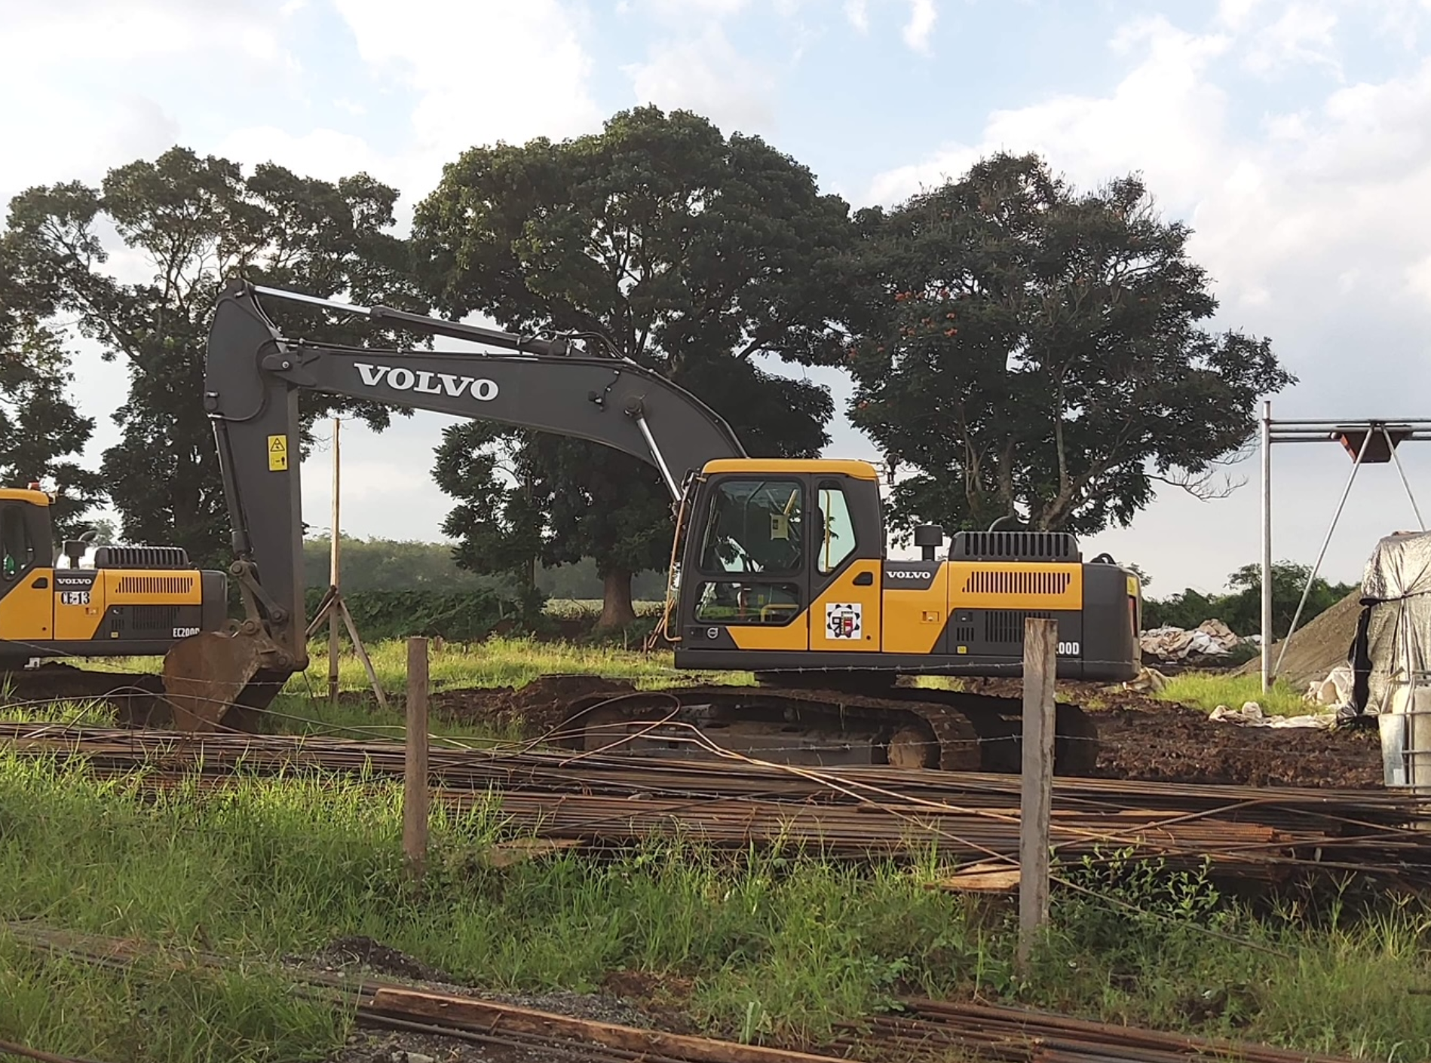
One of RFB Construction Company’s Volvo EC200D crawler excavators

As part of President Duterte’s Build Build Build initiative, Philippines contractor RFB Construction Company has used a fleet of excavators and soil compactors from Volvo Construction Equipment to complete projects on time and on budget.

RFB Construction Company, together with Rodnet Builders, has brought multi-million construction projects to a successful close, including Mindanao’s largest sports complex. In this endeavour, the contractor commissioned machinery from Volvo Construction Equipment (Volvo CE) to facilitate the heavy works in the field and on project sites.

The fleet of equipment included Volvo EC210D and EC200D crawler excavators, EW145B wheeled excavators and SD110 soil compactors. Some of the excavators were equipped with hydraulic breakers to cope with the hard rock formations, especially for the road construction.

“Productivity and uptime were crucial to keep this project on schedule and within budget, so we needed quality, durable machines with high parts availability and responsive service support,”
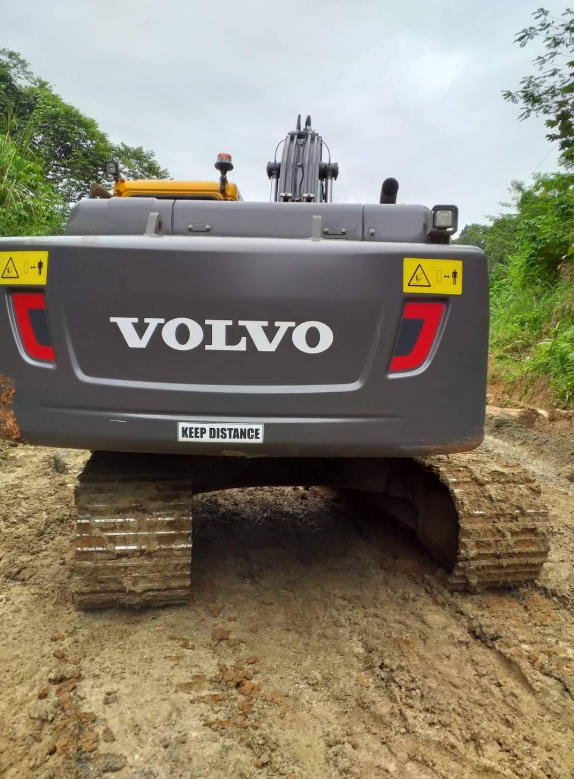
explains Roger F. Bustillo, president and CEO of RFB Construction company.

Tougher than the rest
“We chose equipment from Volvo because it is stronger and easier to operate compared to other machines – and capable of handling continuous projects cost efficiently,” he continues.

RFB Construction Company and Rodnet Builders’ machines are required to work long hours across more than one shift a day, especially in critical areas. Over the course of the project, the Volvo excavators and soil compactors exceeded RFB Construction Company and Rodnet Builders’ quality expectations.

“The Volvo EW145B wheeled excavator, in particular, greatly contributed to our productivity when combined with the crawler excavator and other Volvo machines,” says Roduard Michael C. Bustillo, vice-president and COO of RFB Construction Company.
A Volvo crawler excavator handles the muddy terrain at RFB Construction Company’s site in Bukidon province with ease.

Swift aftersales support
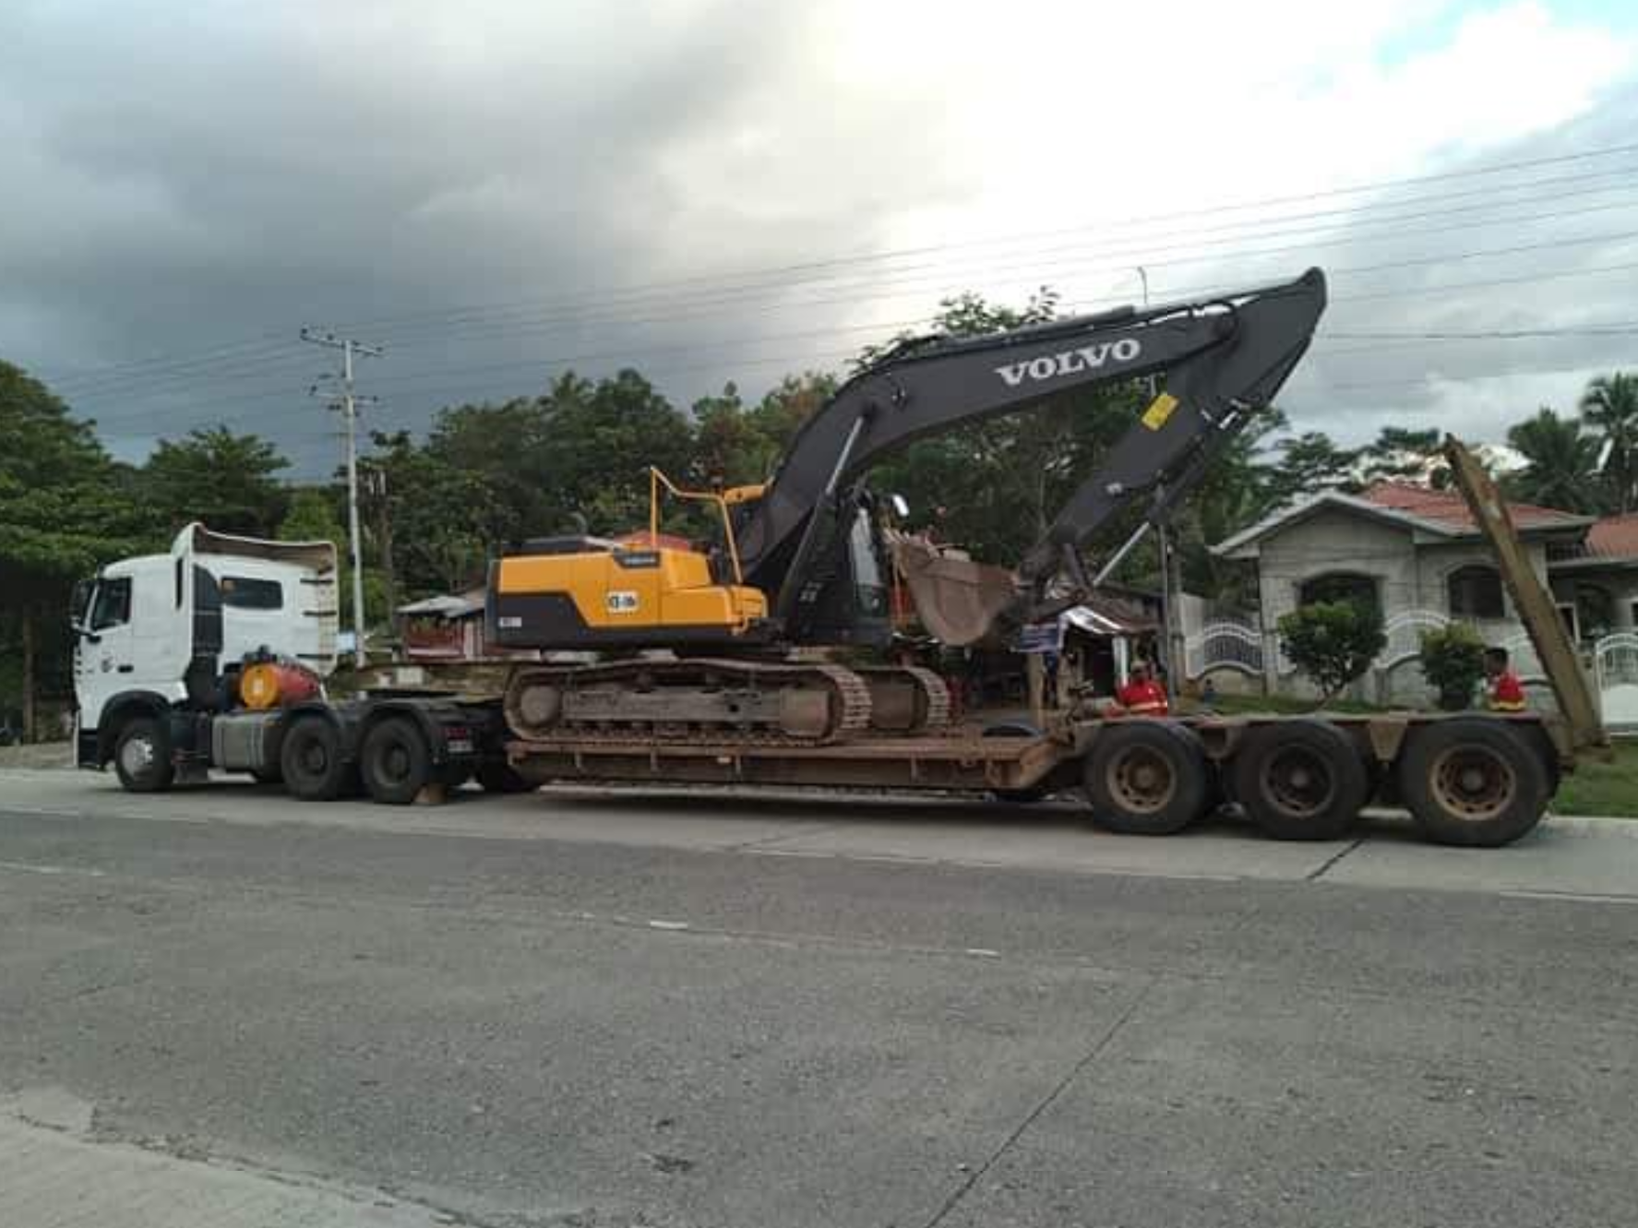
The contractor was equally impressed by the aftersales support from local dealer Civic Merchandizing, Inc./Topspot Heavy Equipment.

“We appreciate the speedy support from the sales and service team at Civic Merchandizing, Inc./Topspot Heavy Equipment. When the Volvo machines needed repairs it was very quick. It is great to have the quality assured,” adds Rodnick C. Bustillo, vice-president for equipment at the two companies.

This is not the only project in the Philippines where the high productivity and uptime of Volvo excavators and compactors have proved key to success. All across the country, Volvo machines are helping to get jobs done quickly, efficiently and cost-effectively.
Volvo excavators are simple to transport to and from the jobsite.

Ends.
September 2021

Journalists with enquiries, please contact:

Marta Benitez  Head of Brand & Corporate Communication  Region Asia & Region China  Volvo Construction Equipment  marta.benitez@volvo.com | Hannah Kitchener  SE10  +44 207 923 586  hannah.kitchener@se10.com

For more information, please visit www.volvoce.com/asia

For frequent updates, follow us on
Twitter: @VolvoCEGlobal
LinkedIn: @VolvoConstructionEquipment
Facebook: @volvoceasia
Instagram: @volvoceasia
YouTube: @volvoceasia

Volvo Construction Equipment (Volvo CE) is a leading international manufacturer of premium construction equipment, and with over 14,000 employees, it is one of the largest companies in the industry. Volvo CE offers a wide range of products and services in more than 140 countries through its global distribution network. Volvo CE is part of the Volvo Group. The Volvo Group drives prosperity through transport solutions, offering trucks, buses, construction equipment, power solutions for marine and industrial applications, financing and services that increase our customers’ uptime and productivity. Founded in 1927, the Volvo Group is committed to shaping the future landscape of sustainable transport and infrastructure solutions. The Volvo Group is headquartered in Gothenburg, Sweden, employs 105,000 people and serves customers in more than 190 markets. In 2020, net sales amounted to about SEK 338.4 billion (EUR 33.3 billion). Volvo shares are listed on Nasdaq Stockholm.

