PRESS INFORMATION

Reliability and fuel efficiency of Volvo EC210D excavator satisfy Indonesian customer

Indonesian owner-operator Mr. Happy New Year is using a Volvo EC210D to load sand from a river into a crusher at a sand mine in central Java and is pleased with the reliability and fuel-efficiency of the excavator, even on tough terrain.

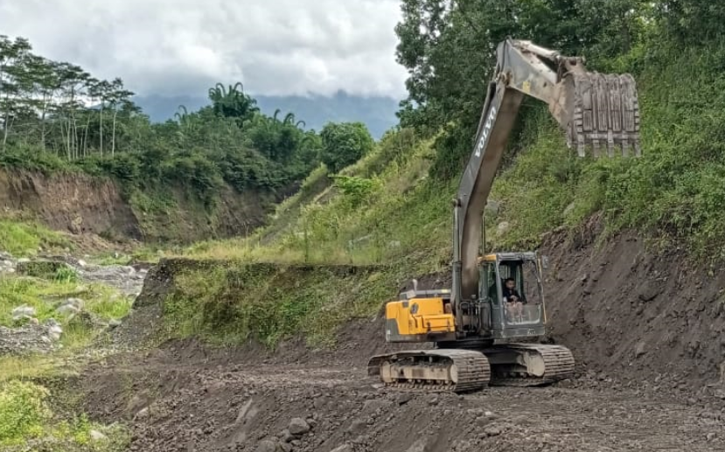

At a sand mine in central Java, Indonesia, one Volvo customer is not just happy by name; he is happy in his work. Mr. Happy New Year has been operating a Volvo EC210D excavator at his site in Borobudur, Magelang, since 2017 to load sand from the river into a crushing unit and is pleased with the reliability and fuel-efficiency of the machine.
He uses the EC210D continuously for 8-10 hour shifts every day and it never fails to deliver. “I chose the Volvo EC210D over excavators from other brands because of the good performance, reliability and quality of the unit over a long life cycle,” he said.

The EC210D is built with durable components for outstanding results in all applications, securing lasting machine value and an excellent return on investment. Mr. Happy New Year intends to continue using the EC210D for a further five to eight years, during which time he expects it to generate considerable savings in fuel consumption. “The Volvo EC210D is very efficient in fuel consumption,” he enthuses.
Exceptionally efficient
The robust Volvo engine is perfectly matched to the hydraulics, delivering high torque at low rpm for the ultimate combination of performance and fuel efficiency. For fast cycle times and optimum fuel consumption, Mr. Happy New Year is able to choose between five work modes – I (Idle), F (Fine), G (General), H (Heavy) and P (Power Max) – according to the demands of the task.
Another important factor for Mr. Happy New Year is the safety and stability of the machine. His sand mine is located in an active volcanic area with steep inclines, eruptions and landslides. The EC210D maintains a good grip on the slippery slopes, while the all-round visibility of the cab gives a commanding view, helping him to complete his work safely and productively.
Maintenance made easy
As with any piece of machinery, there will inevitably be some maintenance requirements from time to time, for which Mr. Happy New Year counts on the support of local Indonesian Volvo dealer PT Indotruck Utama. “The dealer is always quick to troubleshoot and resolve any issues, helping me and my machine to get back to work as soon as possible,” he explains.
For daily servicing, anti-slip plates, grouped filters, ground-level service access and centralized lubrication points make checks quick and easy. Longer term, the large service intervals enhance machine availability and increase uptime for maximum productivity.
With a reliable, fuel-efficient machine and responsive service support, it is no surprise that Mr. Happy New Year is another happy Volvo customer.
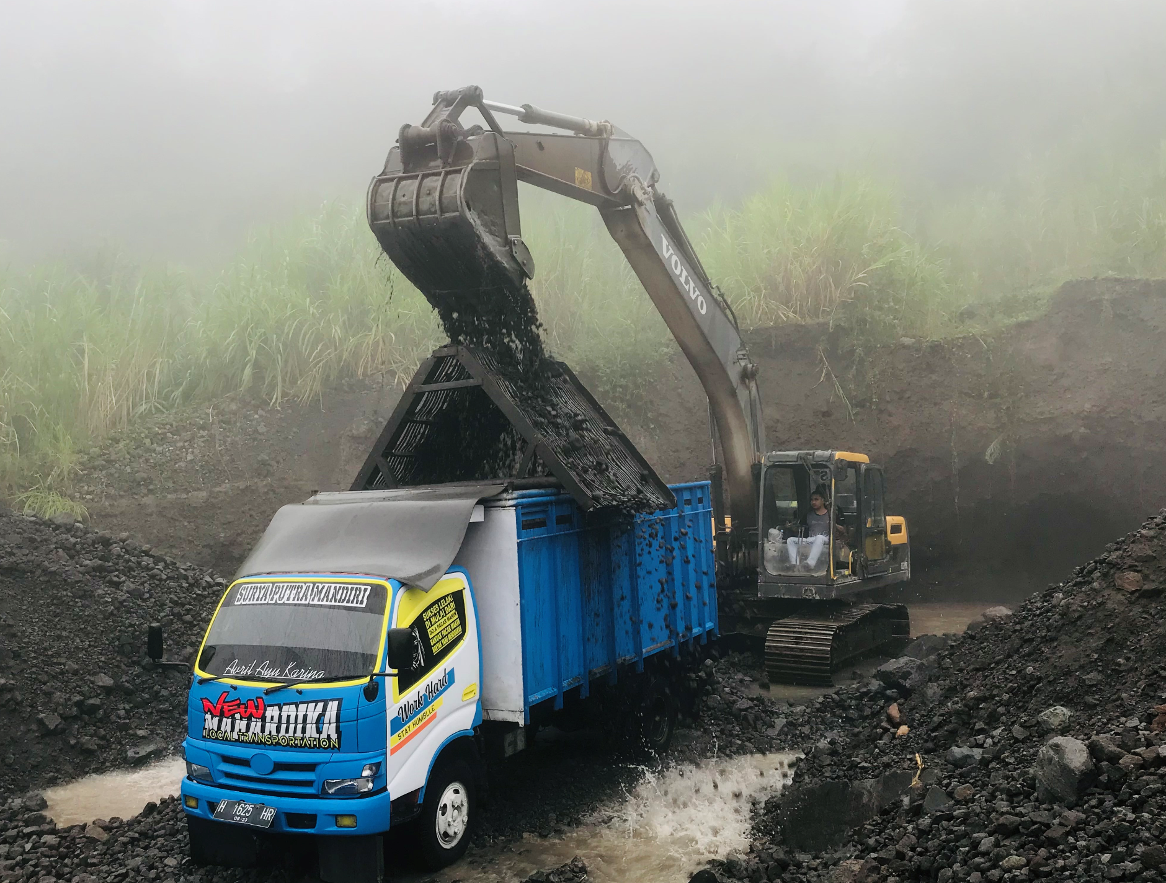
Ends.
May 2021
For further information, please visit: https://www.volvoce.com/asia

Or contact:

Tiffany Cheng | Hannah Kitchener
Head of Brand, Marketing & Corporate | SE10
Communication | T: +44 207 923 5863
Region Asia and Region China | E: hannah.kitchener@se10.com
Volvo Construction Equipment
E: tiffany.cheng@volvo.com

Volvo Construction Equipment (Volvo CE) is a leading international manufacturer of premium construction equipment, and with over 14,000 employees, it is one of the largest companies in the industry. Volvo CE offers a wide range of products and services in more than 140 countries through its global distribution network. Volvo CE is part of the Volvo Group. The Volvo Group drives prosperity through transport solutions, offering trucks, buses, construction equipment, power solutions for marine and industrial applications, financing and services that increase our customers’ uptime and productivity. Founded in 1927, the Volvo Group is committed to shaping the future landscape of sustainable transport and infrastructure solutions. The Volvo Group is headquartered in Gothenburg, Sweden, employs over 100,000 people and serves customers in more than 190 markets. In 2020, net sales amounted to about SEK 338.4 billion. Volvo shares are listed on Nasdaq Stockholm.

