P R E S S R E L E A S E

Indo Muro Kencana connects 59 machines to Volvo ACTIVE CARE

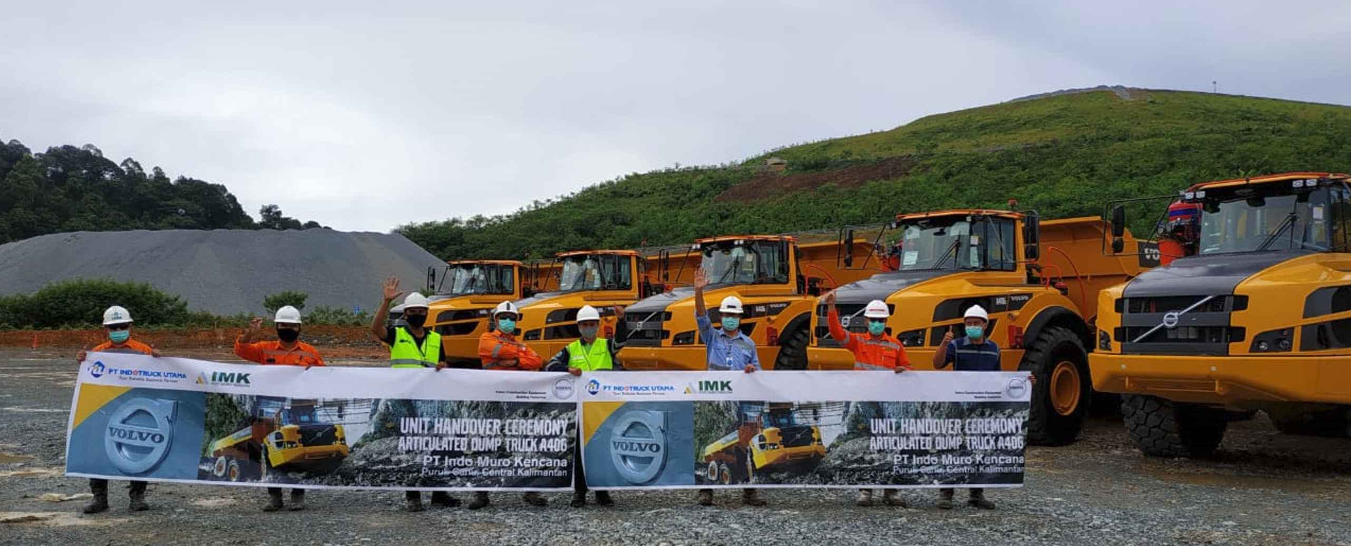
IMK celebrates the addition of several new A40G haulers to its fleet.
Through proactive monitoring and preventative maintenance, Volvo ACTIVE CARE will support the Indonesian gold miner to achieve greater uptime and, therefore, greater productivity and profitability from its fleet of haulers and excavators.

Indo Muro Kencana (IMK) now has Indonesia’s the largest fleet of machines connected to Volvo ACTIVE CARE, including 52 A40G articulated haulers and seven crawler excavators (five EC480DL and two EC750DL models).

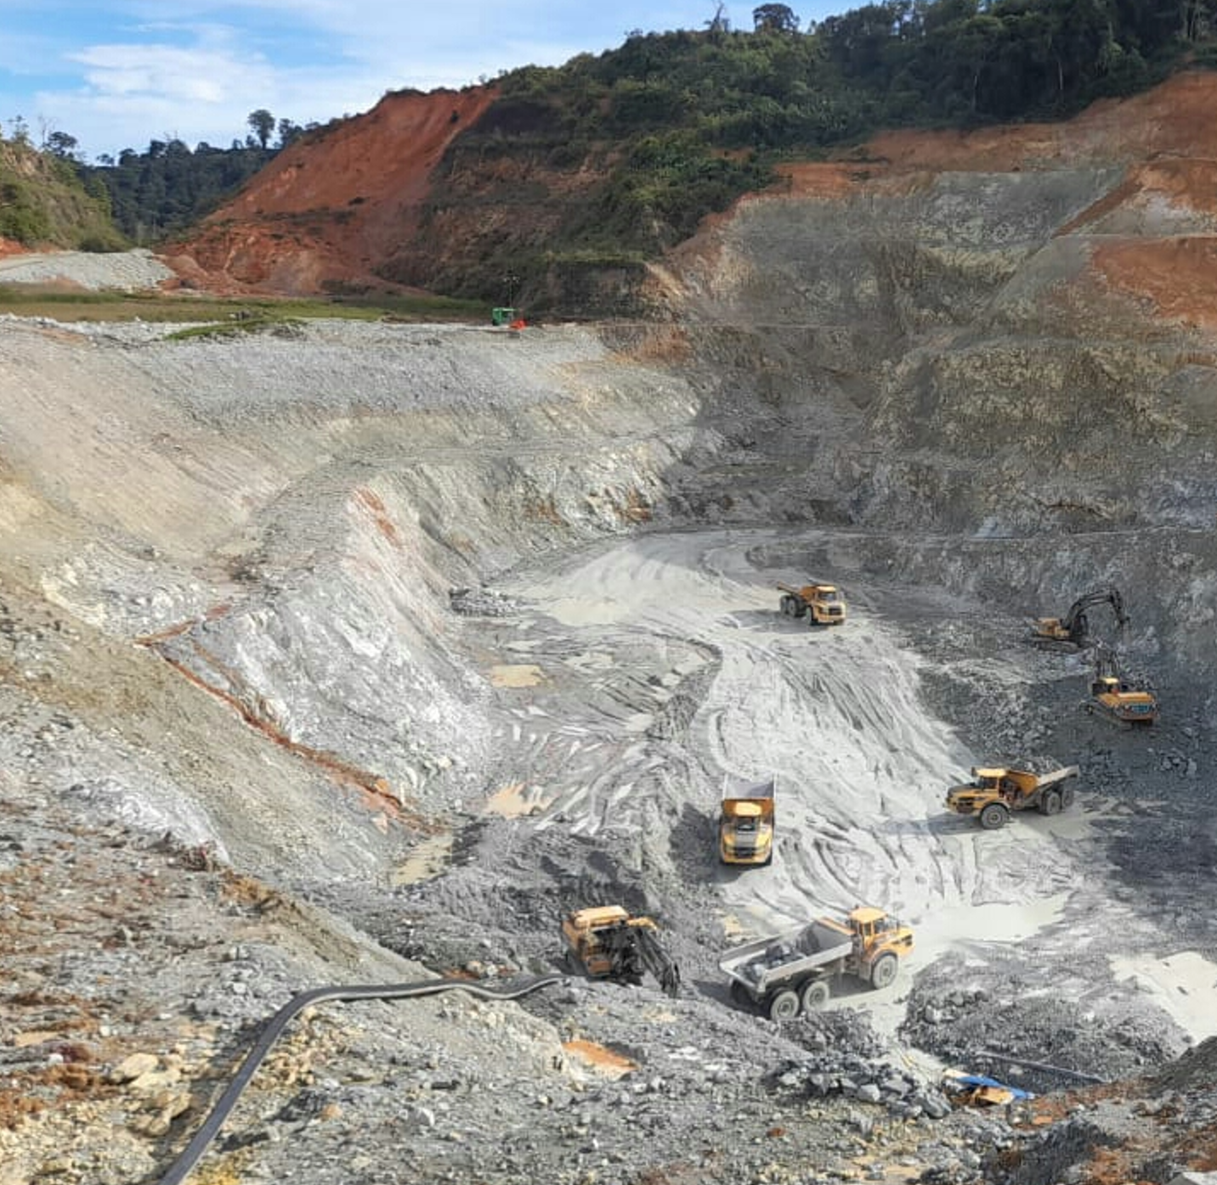
The gold exploration and mining company, based in Central Kalimantan, recently took the decision to connect its machines to the new proactive monitoring service in a bid to boost machine availability and production. Although still early days, IMK anticipates that Volvo ACTIVE CARE will increase machine availability to 92% and productivity by 32% as a result.

“Our machines work long hours to meet production targets and we cannot afford to lose production due to unscheduled downtime. Volvo ACTIVE CARE will take us from reactive maintenance and repair behaviours to being proactive about the uptime of our fleet,” said Mr. Julianto, maintenance superintendent at IMK.
Overview of an IMK gold mine in Central Kalimantan, Indonesia.

Maintenance manager Mr. Karsono added: “We are also excited to see how we can use the ACTIVE CARE reports to improve operator behaviour, reduce fuel consumption and improve productivity. For example, we can improve productivity and lower costs just by knowing the idling status of the fleet and setting targets to reduce it.”

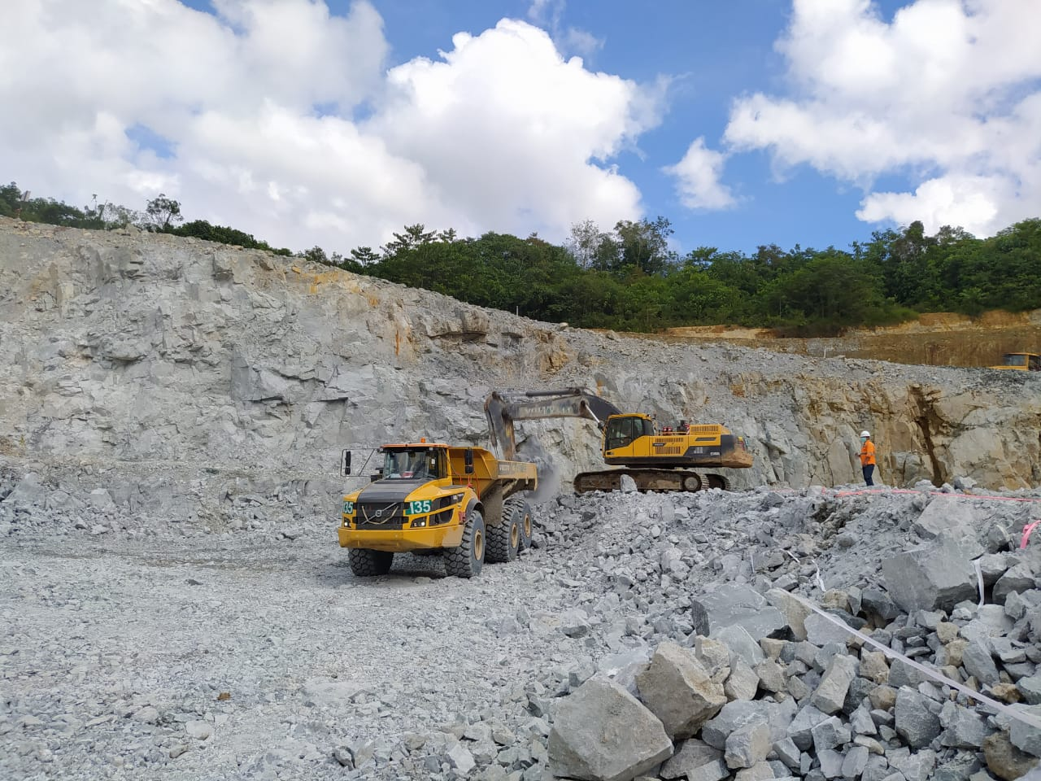
Volvo machines working at the IMK gold mine in Central Kalimantan, Indonesia.

Preventing breakdowns before they happen

Using Volvo CareTrack telematics data, staff at the Volvo Uptime Center in Singapore will remotely monitor the performance of IMK’s machines as well as any error codes or alarms that appear. If there is a severe error that might lead to breakdown, the Uptime Center will create a case and contact the local dealer Indotruck Utama to suggest an action to replay to IMK.

This takes the hassle out of fleet management and IMK can rest assured that any potential problems will be noticed and addressed before they lead to costly unplanned downtime. With Volvo ACTIVE Care, their machines will always be ready to work when needed.

Ends.
October 2021

Journalists with enquiries, please contact:

Marta Benitez
Head of Brand & Corporate Communication
Region Asia & Region China
Volvo Construction Equipment
marta.benitez@volvo.com

For more information, please visit http://www.volvoce.com/asia

Volvo Construction Equipment (Volvo CE) is a leading international manufacturer of premium construction equipment, and with over 14,000 employees, it is one of the largest companies in the industry. Volvo CE offers a wide range of products and services in more than 140 countries through its global distribution network. Volvo CE is part of the Volvo Group. The Volvo Group drives prosperity through transport solutions, offering trucks, buses, construction equipment, power solutions for marine and industrial applications, financing and services that increase our customers’ uptime and productivity. Founded in 1927, the Volvo Group is committed to shaping the future landscape of sustainable transport and infrastructure solutions. The Volvo Group is headquartered in Gothenburg, Sweden, employs 105,000 people and serves customers in more than 190 markets. In 2020, net sales amounted to about SEK 338.4 billion (EUR 33.3 billion). Volvo shares are listed on Nasdaq Stockholm.

