P R E S S R E L E A S E

Volvo moves to zero with decarbonization showcase at Intermat 2024

Innovation and pioneering partnership will be at the forefront of a platform of sustainable solutions from Volvo Construction Equipment (Volvo CE) at Intermat 2024 in Paris, France.

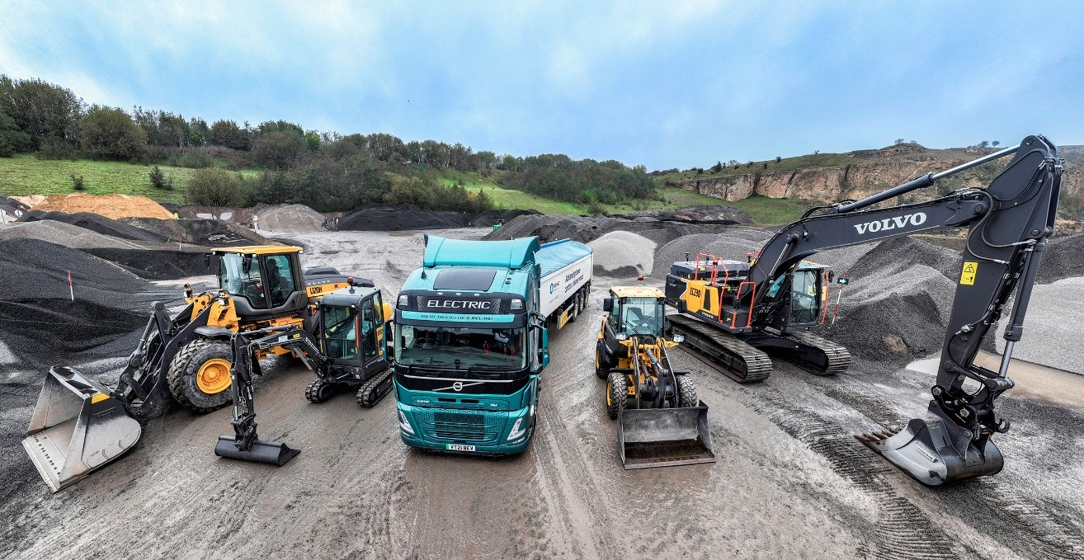

Volvo CE France, together with colleagues across Volvo Group, will showcase an all-inclusive decarbonization pathway for the entire construction industry that covers powerful battery electric equipment and commercial vehicles, hydrogen fuel cell prototypes, smart services and efficient charging solutions.

On a 1.500 m² stand Volvo will display today’s decarbonization in action. Alongside a number of new and existing innovations, many of which will be kept under wraps until the show itself, will be the 23-ton EC230 Electric excavator and the new L120 Electric wheel loader, as well as some of the smaller electric compact machines such as the EC18 Electric excavator.

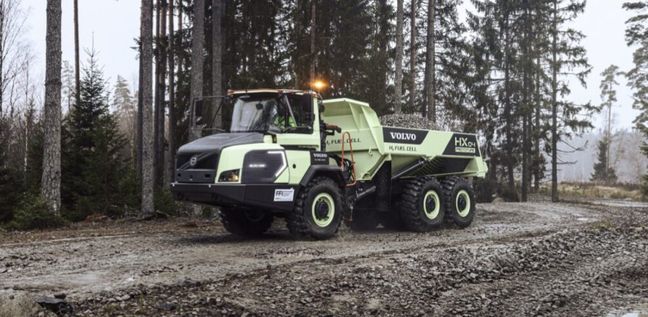
The Volvo HX04 is the world's first articulated hauler hydrogen fuel cell prototype
Proving that multiple technologies are needed to support our industry’s transition, the world’s first prototype hydrogen fuel cell articulated hauler, the HX04, will also be highlighted, alongside other pioneering solutions such as those powered by renewable biofuels.

With services taking on a more prominent role at Intermat, 2024 Volvo CE will display Productivity Services such as Connected Map, Task Manager and its pioneering Equipment as a Service model, as well as Parts and Uptime Services such as the CO2 Reduction Program. Volvo Financial Services will be part of the Volvo stand to present its wide offer of financing solutions.

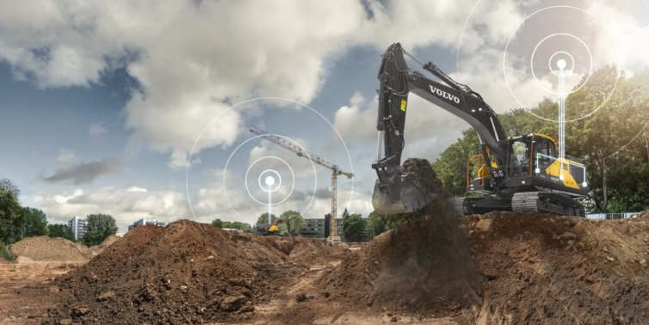
Volvo CE will present its pioneering Productivity and Parts and Uptime services
The electric transformation would not be complete without a demonstration of the company’s leading range of charging solutions and mobile power units, for both lighter equipment and heavy-duty long-haul commercial vehicles.

Knowing that the sustainability shift is a journey our customers cannot achieve in isolation, Volvo CE’s products and services will stand shoulder to shoulder with 100% electric solutions from Volvo Trucks and Volvo Penta.

Moving to zero, together

It is a platform that proves that Volvo is a trusted brand when it comes to delivering a net zero future across different transport streams – and that it is more committed than ever to achieving carbon neutrality by 2040.

Through product and service innovation, it is demonstrating that electric construction equipment has the power to work seamlessly together with electric trucks, all the while supported by reliable and holistic charging solutions.

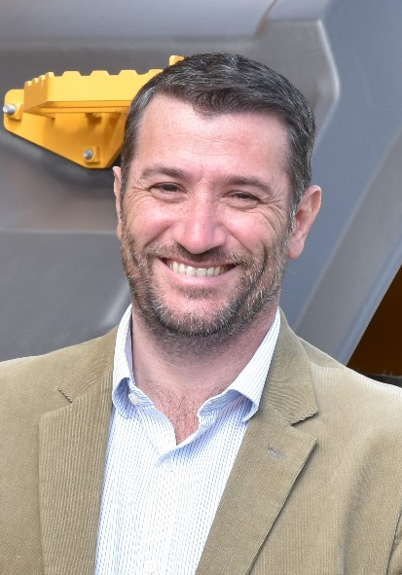
Davy Guillemard, Head of Market Area France, Volvo CE, says: “We are leading our industry transformation, both in France and around the world, with our unique and holistic offering of sustainable solutions. Our customers benefit from the expertise across Volvo Group, resulting in our broad range of electric products, charging solutions and smart services.”
Davy Guillemard
Marcus Horberg, President Volvo Trucks France, says: “It is together that we can mobilize to create a safer, quieter world free from harmful pollutants. Working in partnership across the Group, we are better able to respond to the environmental challenges of our planet and support our customers in making that transformation too.”

Taking place April 24-27 at the Paris-Nord Villepinte Parc des Expositions in Paris, the tri-annual construction summit is returning with a revamped exhibition format covering earthmoving, demolition and transportation, roads, minerals and foundations, lifts and handling and the buildings and concrete sector.

It will be the first time Intermat has been staged since the 2021 event was forced to cancel due to the insurmountable challenges presented by the Covid-19 pandemic.

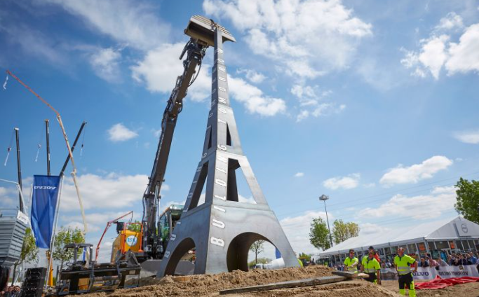
Volvo CE at the last Intermat in Paris, France, 2018

January 2024

Journalists wanting further information, please contact:

Sandra Jansen
Media Relations & Communications Manager
Volvo Construction Equipment Germany GmbH
E-Mail: sandra.jansen@volvo.com

For more information, please visit www.volvoce.com

For frequent updates, follow us on
Twitter: @VolvoCEGlobal
LinkedIn: @Volvo Construction Equipment
Facebook: @VolvoCEGlobal
Instagram: @VolvoCE
YouTube: @Volvo Construction Equipment

Volvo Construction Equipment (Volvo CE) is a global leader in construction solutions, delivering premium products and services that combine power and performance with a more sustainable way of working. We are a company driven by people and together we have a purpose: To build the world we want to live in. Founded in 1832 and with a distribution network across every major market, our many dedicated experts around the world are fulfilling our shared purpose through a focus on sustainability, electromobility and services. As well as our expanding range of electric machines and charging solutions, Volvo CE provides industry-leading haulers, loaders, excavators and much more, all built to suit the demands of our customers’ varied construction and infrastructure needs. Volvo CE benefits from being connected to the Volvo Group, which also offers trucks, buses, power solutions for marine and industrial applications, financing and services that increase our customers’ uptime and productivity. Through its holistic perspective, Volvo Group is committed to shaping the future landscape of sustainable transport and infrastructure solutions. For further company information and to explore our values further please visit www.volvoce.com

